**PROJECT REPORT TEMPLATE**

**IMPLEMENTING CRM FOR RESULTS TRACKING OF A CANDIDATE WITH INTERNAL MARK**

**INTRODUCTION**

**Administrator should be able to create all data base including Semester, Candidate,**

**Course and Lecturer. Lecturer should have the ability to create Internal Results. Dean,**

**Who is one of the Lecturer, should be the only authority m update Internal**

**Results. Re-evaluation can be initialised by Candidate for all Internal Results. Now**

**Only dean can update the marks after re- evaluation.**

**By internal marks it means that your marks obtained by your assignment or other co-curricular activities or your behavior most important. It is the marks that is given by your teacher to you. The marks you obtained in your exam or theory is external marks.**

**PROBLEM DEFINITION AND DESIGN THINKING**

**EMPATHY MAP**

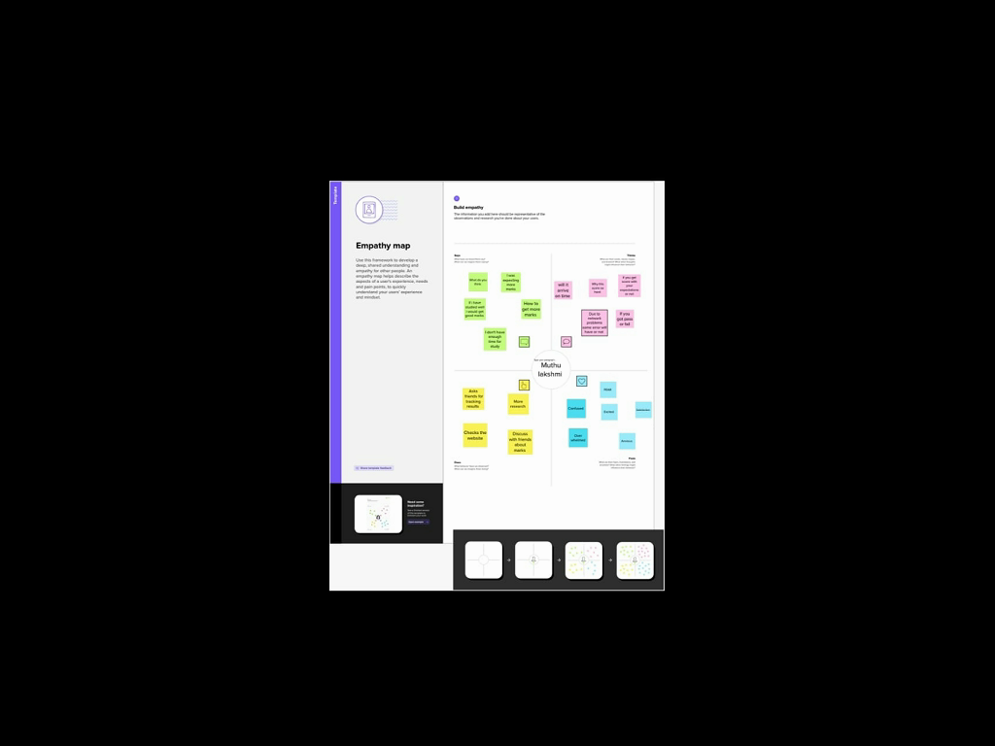

**IDEATION AND BRAINSTORMING**



**DATA MODEL**

**Data Model**

|  |  |  |  |  |  |
| --- | --- | --- | --- | --- | --- |
| **Object 1**  **Semester** | |  |  | | --- | --- | | **Field Label** | **Data Type** | | **Semester** |  | |
| **Object 2**  **Candidate** | |  |  | | --- | --- | | **Field Label** | **Data Type** | | **Semester** |  | |
| **Object 3**  **Course Details** | |  |  | | --- | --- | | **Field Label** | **Data Type** | | **Semester** |  | |
| **Object 4**  **Lecturer Details** | |  |  | | --- | --- | | **Field Label** | **Data Type** | | **Semester** |  | |
| **Object 5**  **Internals Result** | |  |  | | --- | --- | | **Field Label** | **Data Type** | | **Semester** |  | |

**ACTIVITY AND SCREENSHOT**

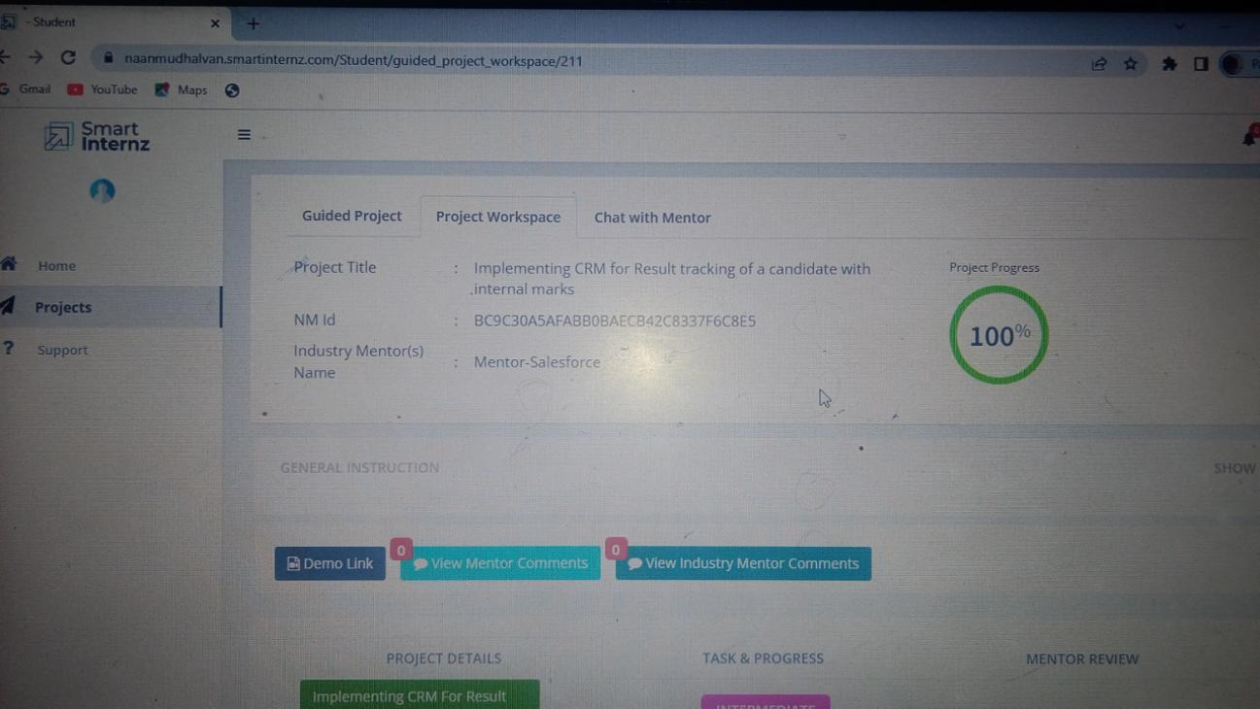

**TRAILHEAD PROFILE PUBLIC URL**

**Team leader; https://trailblazer.me/id/mlakshmi227**

**Team Member ;https://trailblazer.me/id/nithd7**

**Team Member ;https://trailblazer.me/id/lgeetha4**

**Team Member ;httpa://trailblazer.me/id/lwari4**

**ADVANTAGES**

**It allows for the consolidation of customer data and the basis for deep insights.**

**It speeds up the sales conversion process.**

**It increases staff productivity, lowering time-cost.**

**It allows geographically dispersed teams to collaborate effectively.**

**Improves customer experience by allowing personalisation and improved query resolution**

**DISADVANTAGE**

**Customer experience may worsen due to staff over-reliance on the system.**

**Security and data protection issues with centralised data.**

**The excess initial time and productivity cost at the implementation.**

**Requires a process-driven sales organisation.**

**CRM may not suit all businesses.**

**APPLICATION**

**The college is particular as far as the attendance is concerned. It is mandatory for all students to maintain a minimum attendance of 75% without which they will not be allowed to appear for their exams. We have been constantly updating our mechanism to monitor attendance and academic performance. We have an integrated Campus Management System (CMS) based on latest cloud computing technology. CMS provides students direct access to their hourly attendance through individual student accounts. Reference material, Videos, Internal assessment marks as well as study material is posted on the Digitacampus site.**

**Individual student’s account with login and password.**

**Login and password for Director to access/ track student information regularly.**

**Mechanism for Director to check progress in syllabus completion**

**No manual entries, no attendance registers.**

**SMS to students to communicate important information.**

**Feedback on faculty performance by students taken online.**

**CONCLUSION**

**The findings of this study support anecdotal evidencethat there is a significant positive**

**Classattendance and academic achievement.The findings of this study will be useful in shapinginstitutional policies regarding attendance monitoring.Following recommendations can be proposed-Summary of these findings can be presented to thestudents which can act as a motivator and encouragestudents to maintain high levels of attendanceEstablish an attendance monitoring system for trackingstudents with poor attendance pattern so as to take action toaddress the issue at the earliest.**

**FUTURE SCOPE**

**The timeline for the implementation of a new CRM system depends on the size of the business and its various departments. However, most small businesses can expect implementation to last one to three months. Other key variables include which CRM solution you choose, whether you hire outside assistance in data migration and system testing, any training or consulting programs the CRM provider offers, and the quality and quantity of data you currently possess.**